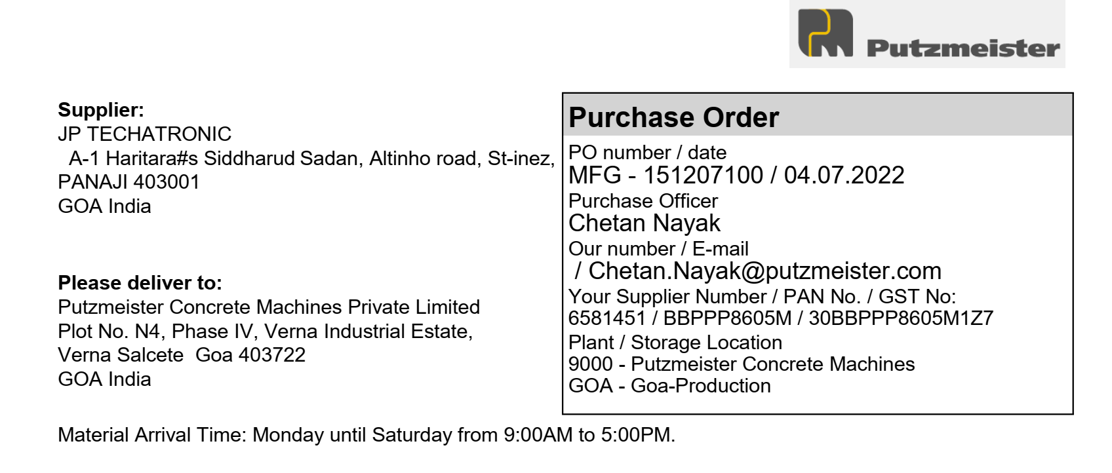

|  |  |  |  |  |  |  |
| --- | --- | --- | --- | --- | --- | --- |
| **Sr. No** | **Material** | **Description** | **Quantity** | **Unit** | **Price Per Unit** | **Net Price (INR)** |
| 1 | 719381 | Monochrome laserjet printer CanonLBP6030BJ | 5 | PCS | 8299 | 41495 |
|  |  |  |  | CGST | 9% | 3734.55 |
|  |  |  |  | SGST | 9% | 3734.55 |
| Delivery Schedule |  |  |  | Basic Total | | 41495 |
| Date | 25.07.2022 |  |  | Central GST | | 3734.55 |
|  |  |  |  | State GST | | 3734.55 |
|  |  |  |  | **Total In INR** | | **48964.1** |

Amount In Words:

Forty Eight Thousand Nine Hundred Sixty Four Rupees Ten Paise



It is necessary to put the Putzmeister order number on every invoice.

Terms and conditions applied.



